Healthy Schools BC Regional Grants 2019-2020 are now available!

The Healthy Schools BC Regional Grants support education and health-sector partners to work together on initiatives that support healthy schools, with the intention of strengthening their partnership.
This package includes the grant information, application form and final reporting requirements.

Grant applications are due October 15th, 2019

Questions?

Please contact hsbc@dashbc.ca for more information.

Healthy Schools BC Regional Grants
Information
This package includes Healthy Schools BC Regional Grant information, including eligibility requirements, evaluation criteria and application questions. To submit an application, complete the form below and submit your application to hsbc@dashbc.ca by
October 15th, 2019.

Introduction

Healthy Schools BC Regional Grants support education and health-sector partners to work together on initiatives that support healthy schools, with a focus on promoting mental health and well-being, and Indigenous ways of wellness.

The World Health Organization defines mental health “as a state of well-being in which every individual realizes his or her own potential, can cope with the normal stresses of life, can work productively and fruitfully, and is able to make a contribution to her or his community”.
Indigenous ways of wellness recognize the mental, emotional, spiritual and physical as facets of a healthy, well, and balanced life. Also, that by nurturing all together, it can create a holistic level of well-being in which all four areas are strong and healthy.

Who can apply for a grant?
To support equity across the province, schools districts that have received a Healthy Schools BC Regional Grant consecutively for the past two years (2017/2018 and 2018/2019) are not eligible to apply.

Healthy Schools BC Regional Grants are available to:

- School Districts
- Regional Groups of Public Schools (2 or more)
- Regional Groups of Independent Schools (2 or more)
- Regional Groups of First Nations Schools (2 or more)
Important: Regional Groups means a minimum of two schools working collaboratively in a given school district. An application that involves a single school will not be considered.

The grant application must be submitted and signed by both Grant Partners which include:

- Education Partner:
  - An education partner is a staff member from the school district or a staff member from the regional group of public/independent/First Nations schools, AND

- Health Partner:
  - A Health Partner is a health professional employed with the regional health authority (Vancouver Coastal Health, Island Health, Northern Health, Fraser Health, Interior Health), OR
  - Regional Groups of First Nation schools may use their band’s community health professionals, such as a community health nurse, health director, or dietitian as their Health Partner.

Grant Partners (as described above) are to collaboratively complete the application and are responsible for completing all grant requirements.

Reconciliation

This grant recognizes and is guided by the Principles of Reconciliation, offered by the Truth and Reconciliation Commission of Canada.

Grant Details
Amount: Up to $5,000
Number Available: Maximum 15

Applications will be evaluated based on the following criteria:

- Identifies how the grant will strengthen or build partnerships between the health authority and education partner
- Proposed initiative is strongly connected to mental wellbeing or Indigenous ways of wellness
- Use of evidence (past experience, traditions, proven or promising practice, or research) to inform planned actions
- Clear and feasible plan for action and use of funds (proposed budget)
- Clear and realistic description of how the grant will facilitate meaningful change
- Clear and reaslistic description of how the grant has the potential for sustainable impact
- DASH will seek to reward grants equally throughout the regions
Grant Timeline

Mid-August 2019 | Application process opens. DASH contacts available for information and support
October 15th, 2019 | Application intake closes and review begins
November 2019 | Grant funds distributed
March 2020 | Mid Year Meeting – Grant recipients and DASH
June 1st, 2020 | End of school year report due

Reporting Requirements

Participate in Mid-Year Meeting with DASH
Completion of Final Report (including a financial summary)

How do I submit my application?

Application packages are also available on the Healthy Schools BC website.

Please email your completed application to hsbc@dashbc.ca in either Microsoft Word or PDF format.

Questions

If you have questions about the grant or would like support with your application, please contact: hsbc@dashbc.ca

Healthy Schools BC Regional Grants
Application
To submit an application, complete the form below and submit the completed application to hsbc@dashbc.ca by October 15th, 2019.

Instructions

Please answer each question below. Answers can be submitted in a separate Microsoft Word or PDF document. For the purpose of the application ‘you/your’ refers to the applicants/partners.

Contact Information

Education Partner (School District, Public, First Nations and/or Independent school groups)

Contact Name(s): | Contact Name(s):
SD #/School(s)Name(s): | SD #/School(s)Name(s):
Role: | Role:
Phone #: | Phone #:
Email: | Email:

Health Partner (Regional health authority or First Nations Health Partner information):

Name:
Health Authority/First Nations Health Unit:
Role:
Phone #:
Email:

Scanning and Gathering Evidence

- Describe the current partnership between your school district/group and your regional health authority/community health partner. Please use the Cross Sector Engagement Rubric (Appendix A) to identify your current partner relationship. Please have both the Education and Health Partner answer independently. Max 100-150 words each.

Education Partner’s Response:

Health Partner’s Response:

- What evidence (including past experience, observations, traditions, proven or promising practice, or research) will inform planned actions? Max 350-400 words. May use bullet points.

Focus and Plan

- Briefly describe the priorities of your school district/group in relation to mental health and well-being/ Indigenous ways of wellness in your school community. Max 100 words. May use bullet points.

- Based on the priorities above, indicate the theme that most closely aligns with the focus of your intended initiative by checking one of the following:

- In partnership, explore the connections between physical and mental wellbeing across whole school environments;
- In partnership, explore Indigenous ways of wellness and their impact on supporting wellness across whole school environments;
- In partnership, define and pursue your own approach to supporting the mental wellbeing of students and/or all members of your school community. Please describe your own approach in one clear sentence:

- Please describe your proposed initiative, include the goals you hope to achieve. Max 350 words.

- Provide a brief description of the activities that will occur to implement and complete the work described above. If helpful, you may use the table below (or a similar format). Add rows if needed.

Task | Timeline | Person(s) Responsible

Intended Outcomes

- In what way(s) will this work strengthen or build the relationship between the Grant Parnters? Max 150 words

- How will the grant assist in facilitating meaningful change for your school district or school group community? Max 150 words.

- How will the grant assist in supporting sustainable impact for your goals listed in the previous section? Max 150 words.

Proposed Budget
Financial Summary
The purpose of the financial summary is to outline how you plan to use the Healthy Schools BC Regional Grant funds. There is some flexibility in how the funds can be used, as long as they are used for the direct purpose of the initiative and reflect what was described in the grant application.

All funds are to be spent by June 1st, 2020. After this date, if there is grant money unused it is your responsibility to contact DASH at hsbc@dashbc.ca

Description | Amount
Estimated Total
Grant Partners Please Sign Below:
___________________________ ___________________________
Education Partner Health Partner

Name: Name:
Date: Date:

END OF GRANT APPLICATION
Healthy Schools BC Regional Grants
Final Report

Please submit this Final Report to hsbc@dashbc.ca by June 1st, 2020.

School District:

Partner Names:

Theme

Please indicate which theme you have focused on.

- In partnership, explore the connections between physical and mental wellbeing across whole school environments;
- In partnership, explore Indigenous ways of wellness and their impact on supporting wellness across whole school environments;
- In partnership, define and pursue your own approach to supporting the mental wellbeing of students and/or all members of your school community. Please set out how you described your own approach in your application form:

Overview

1. Describe if/how this grant supported your school district/group’s approach to promoting mental health and well-being/Indigenous ways of wellness in schools.

Partnership

1. Describe if/how the grant impacted the relationship between the partners (e.g. in terms of communication, commitment, shared goals, moving forward).

2. Please use the Cross Sector Engagement Rubric (Appendix A) to identify your current partner relationship.

3. Please provide an estimate of the time commitment that was required from each of the partners to support your initiative.

Reflecting
- What did you achieve? Did you reach the goals you set out to?

- Reflecting on the work this grant supported over the past school year, please briefly share your thoughts on how it went (e.g. what worked well, what you would do differently next time, what advice do you have for future grantees?)

- Describe if the grant facilitated change. If so, was the change meaningful and is it sustainable?

Learnings
- If applicable, share any school district / group learnings you’ve gained.

Financial Summary
The purpose of the financial summary is to outline how you have used the Healthy Schools BC Regional Grant funds. Although you are not required to submit receipts with this summary, you must keep all receipts for 6 months following the submission of the final report, as they may be requested by DASH.
Activity (E.g. forum, meetings, materials, equipment, TOC, guest speaker, etc.) | Amount Spent (dollar amount) | Description (E.g. description of event, what kind of materials or equipment, where it was purchased, purpose for TOC time, etc.)
Total Amount Spent

Additional Comments

Thank you for your efforts!

Appendix A

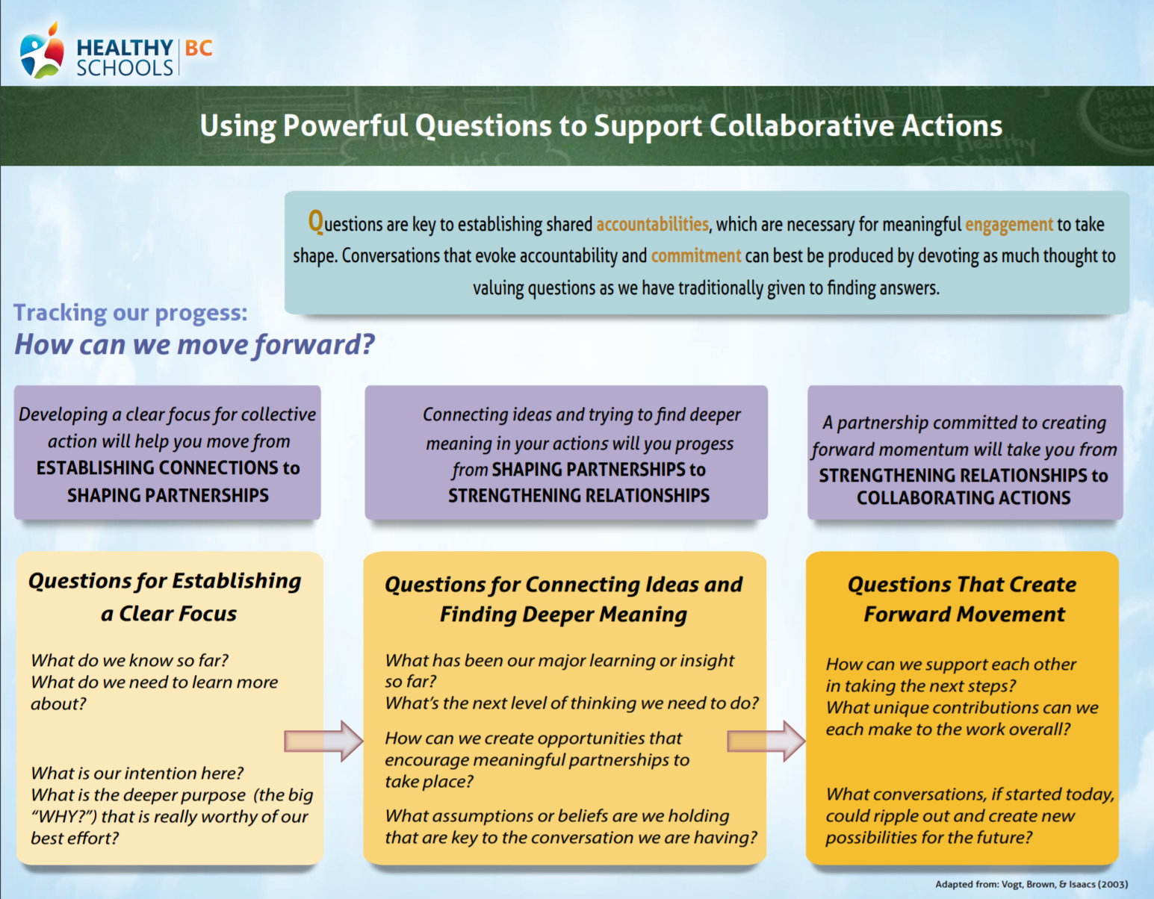

http://www.fnha.ca/wellness/wellness-and-the-first-nations-health-authority/first-nations-perspective-on-wellness

