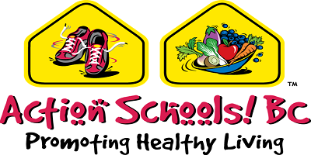

[Insert School Name]

[Insert date here]

Dear Families,

As a part of our Physical and Health Education (PHE) class, your child will participate in an upcoming Food Customs activity. The instructional goal is to celebrate difficult cultures and customs on healthy eating as well as to emphasize for students the importance of eating different vegetables and fruits every day.

In order to create a fun, positive learning environment, where it is engaging for students to learn about different vegetables and fruits, parents/guardians are invited to participate in a "Show and Tell: Sharing and Tasting" event on [Insert date and time].

Parents/guardians paired with their son/daughter are invited to share a favourite family salad recipe with the class and provide a sample that contains a variety of coloured vegetables and fruits for the class. Students will be invited to taste different vegetables and fruits as part of the joint-effort between schools and parents/students to promote healthy eating habits.

Please confirm your participation and attendance by [insert date]. Your support of the Show and Tell activity is helpful. I look forward to working with you and your child on this fun activity. Please do not hesitate to contact me for any reason.

Sincerely,

[Insert Name of Teacher]

Please Return the Confirmation Slip to [Insert Name of Teacher] by [Insert Date]

Name of Parent/Guardian: __________________________________

I will attend the "Show and Tell: Sharing and Tasting" event.

I will share a salad recipe and provide sample for the class to taste.

I will not be able attend the "Show and Tell: Sharing and Tasting" event.

