SPIRAL OF INQUIRY – FOR IMPROVEMENT AND INNOVATION
Developed by Networks of Inquiry and Innovation (NOII) Kaser & Halbert Fall 2011

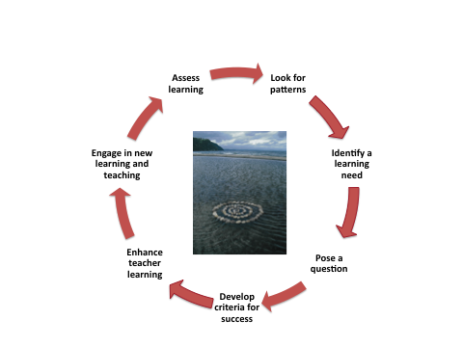

1. Identify the Learning Need

This is the time to consider important sources of evidence and to determine what the focus for your inquiry will be. Think about the following:
- When you carefully reviewed patterns of learning in your setting, what did you identify as a key need for your learners?
- Why is this important?
- What evidence sources did you consider?
- With whom did you consult?
- Is it connected to other priorities in your setting?
- Will a focus in this area increase both quality of learning and equity among learners?

2. Pose a Question

Now is the chance to pose a ‘what if’ question. (Not all questions are of equal value.)

Your question will be a lot stronger if working on it is within your sphere of control or influence – and if it can be addressed reasonably within the span of one school year. You also want to ensure that your question is based on evidence from the learning sciences and / or exemplary emerging practices.

3. Criteria for Success

Having clear criteria for success will help you stay focused and will also help you shift ownership to your learners. Think about this:
- How will you access or co-create learning progressions in your area of inquiry?
- What evidence will you look for that learners are making gains?
- What indications will you look for that learners are more engaged and taking greater ownership of their own learning?

4. Teacher Professional Learning

Teachers are already doing the best they can with the knowledge they currently have. To make significant changes in student learning, adult learning needs must be addressed. Think about the following:

- How will you link teacher learning to the identified learner needs?
- How will you design for differentiated adult learning?
- What content and processes will you use? How will you make the learning engaging for those involved?
- How will you get started? Who will help? Whose help do you need?
- How will you build in multiple opportunities for learning?
- What forms of learning talk will you model and pay attention to?

5. Engaging Learning and Teaching

At the heart of changing outcomes for learners, is changing their learning experiences. Given the strong evidence base regarding formative assessment as the link between motivation, engagement and self-regulated learning, how will you strengthen the focus on formative assessment in your setting? What other new approaches to engaging learning, based on the learning sciences, will you explore?

6. Assess Learning

All through your inquiry you will be assessing the progress your learners are making and making adjustments accordingly. At some point towards the end of the cycle of inquiry, you are going to ask yourself what overall difference have you made for your learners. Think about the following:
- How will you know that what you are doing is making a difference?
- How will learners demonstrate what they are learning?
- What are a range of ways that they will be able to communicate their learning?
- How will parents / families / communities be involved?

7. Identify Patterns

Now is the time to take a step back and with a reflective partner look at the emerging patterns. When you are very close to the learning action, it can be difficult to see the patterns on your own. Inquiry is a team endeavor. Take time to ask yourself:
- What gains have you made for your learners? For your colleagues?
- What has worked particularly well?
- What have been some of the key challenges you have faced?
- What are the continuing areas of challenge or need?
- Where will you go next in a spiral of inquiry to deepen quality and equity?

